

PUBLIC

Data Formatter for Concur Request

This file has been created to assist TMCs with documenting proposals back to a GDS Container PNR as part of the Agency Proposal Powered by Compleat flow.

This file will ensure accuracy when entering the remark lines into the GDS Container PNR and help provide all the mandatory elements to Travel Request.

Table of ContentS

CONFIGURATION 4

GENERAL TAB 5

General Tab completion flow 5

General Tab screenshot example 5

General Tab table of definitions 6

General Tab mandatory information 6

General Tab optional information 7

AIR TAB 8

Air Tab completion flow for one-way 8

Air Tab one-way screenshot example 8

Air Tab one-way table of definitions 9

Air Tab one-way mandatory information 9

Air Tab one-way optional information 10

Air Tab completion flow for round trip 11

Air Tab round trip screenshot examples 12

Air Tab round trip input display 12

Air Tab round trip output display 12

Air Tab round trip table of definitions 13

Air Tab round trip mandatory information 13

Air Tab round trip optional information 15

CAR TAB 17

Car Tab completion flow 17

Car Tab screenshot example 17

Car Tab table of definitions 18

Car Tab mandatory information 18

Car Tab optional information 19

HOTEL TAB 21

Hotel Tab completion flow 21

Hotel Tab screenshot example 21

Hotel Tab table of definitions 22

Hotel Tab mandatory information 22

Hotel Tab optional information 23

RAIL TAB 24

Rail Tab completion flow for one-way rail 24

Rail Tab one-way screenshot example 24

Rail Tab one-way table of definitions 25

Rail Tab one-way mandatory information 25

Rail Tab one-way optional information 26

Rail Tab completion flow for round trip rail 27

Rail Tab round trip screenshot examples 28

Rail Tab round trip input display 28

Rail Tab round trip output display 28

Rail Tab round trip table of definitions 29

Rail Tab round trip mandatory information 29

Rail Tab round trip optional information 31

CONCATENATION 33

Remark separatorS 33

VERSION HISTORY 34

# CONFIGURATION

The “Data Formatter for Concur Request” file has been programmed to perform a concatenation of the remarks generated to allow for more than one remark line to be copied at a time.

**The remarks order must be respected in order to have a successful PNR transmission to Request.**

The configuration for the concatenation varies depending on the tool used to interact with the GDS and the GDS itself. We have therefore allowed for updates to the concatenation character and the number of instances in the output block.

For more information on concatenation use and output examples, please see the Concatenation section below.

Prior to implementation, please determine the correct character and instances for your tool and GDS.

To edit the character and instances:

* Save the file
* Right click the file, and “open with” any document editor.

You will see the following at the beginning of the document:

/********************* Concatenation Variables ***********************/

// Concatenation Characters for each gds

concatStringApollo = "+"

concatStringAmadeus = ";"

concatStringGalileo = "+"

concatStringSabre = "&"

concatStringWorldspan = "#"

// Number of Concatenations for each Gds

lineLimitApollo = 8

lineLimitAmadeus = 8

lineLimitGalileo = 28

lineLimitSabre = 79

lineLimitWorldspan = 80

* To update the character, amend the concatString value inside " "
* To amend the number of concatenation instances, amend the lineLimit value after =[space]
* Save the changes
* Test the output against your GDS interaction tool, ensuring that the maximum value of instances is achieved

# GENERAL TAB

This tab is used to add mandatory information remarks to the GDS Container PNR.

This will be the landing page when the file is opened.

N.B. This document uses Apollo remark examples only.

## General Tab completion flow

Flow

Fill in any optional information

* Proposal Expiry Date and Time
* Agency Branch Offset to GMT/UTC
* Remarks

Copy and Paste into the GDS Container PNR

Fill in **all** mandatory fields

Marked with a red asterisk

* “Locator”
* “Select a GDS”
* “Select a Proposal Number”
* Check or uncheck “Booked” as applicable

Click on “Generate Code”

## General Tab screenshot example

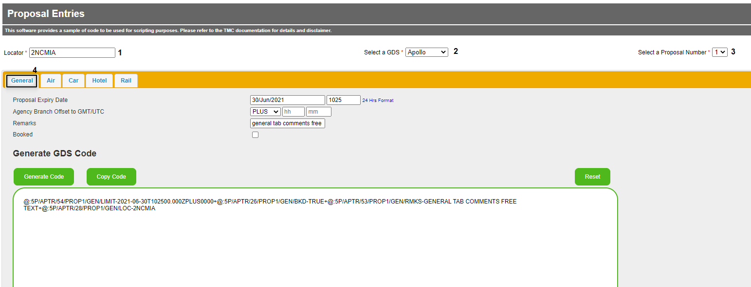

This step must be performed for each proposal before adding the related segment remark data into the PNR.

## General Tab table of definitions

### General Tab mandatory information

| File input  and description | PNR Remark label | PNR Remark example |
| --- | --- | --- |
| (1) Locator  This is the record locator of the container PNR that the customer will use in any communication.  It can be either the GDS Container PNR locator or the locator of an additional booking. | LOC- | LOC-2NCMIA |
| (2) Select a GDS  This is where you choose the GDS (in our example Apollo) needed to generate the Container PNR. | Drop down choice on file | @:5P/APTR… |
| (3) Select a Proposal Number  This is where you select the proposal number (3 is the maximum).  Each proposal must be entered in turn. After each is completed (and copied and pasted) the data for the next proposal can be updated. | PROP1 | @:5P/APTR/54/PROP1/… |
| (4) General  This tab is used to fill in the general information that is needed for the GDS Container PNR. | GEN | @:5P/APTR/54/PROP1/GEN/… |

### General Tab optional information

| File input  and description | PNR Remark label | PNR Remark example  with default values |
| --- | --- | --- |
| Proposal Expiry Date  This is the expiry date and time of the proposal.   * Date is in the format DD/MMM/YYYY * Time is in the format HHMM and is 24 hours | LIMIT-  T- | LIMIT-2021-06-30  T102500.000  (shows as LIMIT-/ if blank) |
| Agency Branch Offset to GMT/UTC  This is the agency branch time zone.  This works in conjunction with the Proposal Expiry so that the correct time can be applied adjusting any offset.  Select if the Offset is MINUS or PLUS GMT/UTC   * Date is in the format DD/MMM/YYYY * Time is in the format HHMM and is 24 hours | ZPLUS | ZPLUS0000  (not shown if blank) |
| Remarks  This is a free text field for any additional information. | RMKS- | RMKS-GENERAL TAB COMMENTS FREE TEXT  (shows as RMKS-/ if blank) |
| Booked  Select this option if you have pre-booked a proposal for policy compliance reasons. This will be shown to the traveller in the next version of Agency Proposal user interface v2.  The default is unchecked | BKD- | BKD-FALSE  (default value) |

## AIR TAB

This is where you complete the details for a single or return air segment.

### Air Tab completion flow for one-way

Flow

Fill in any optional information required

* “Confirmation Number” – only when “Booked” is unchecked
* “Flight Duration”
* “Departure Terminal”
* “Arrival Terminal”
* “Policy Compliance Level (%)”
* “Comments”
* “Meals”
* “Seat Number”
* “Equipment”

Copy and Paste into the GDS Container PNR

Fill in **all** mandatory fields

Marked with a red asterisk

* Select “One way”
* Check or uncheck “Booked” as applicable
* “Currency”
* “Fare”
* “Departure IATA”
* “Arrival IATA”
* “Flight number”
* “Confirmation Number” – only when “Booked” is checked.
* “Departure Date” and “Time”
* “Arrival Date” and “Time”
* “Airline Class”

Click on “Generate Air Code”

### Air Tab one-way screenshot example

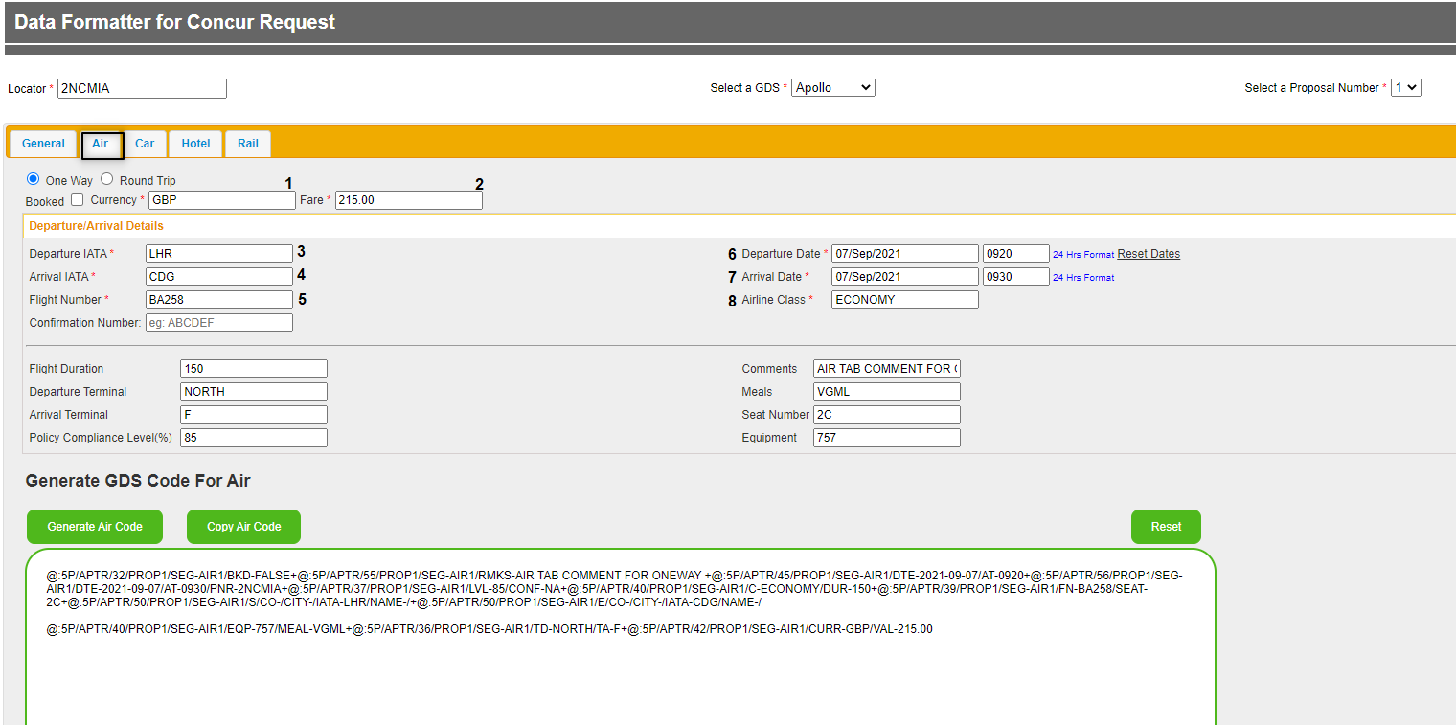

## Air Tab one-way table of definitions

### Air Tab one-way mandatory information

| File input  and description | PNR Remark label | PNR Remark example |
| --- | --- | --- |
| AIR – One Way  This is the Air segment tab to fill in the information for | SEG- | SEG-AIR1 |
| (1) Currency  This is the three-letter ISO standard code for the currency used. For example: GBP, EUR… | CURR- | CURR-GBP |
| (2) Fare  This is the total amount of the Air segment.  It will automatically format to 2 decimal places if not typed.  We currently only support decimalized currencies | VAL- | VAL-215.00 |
| (3) Departure IATA  This is the three-letter IATA airport code for the departure. | IATA | IATA-LHR |
| (4) Arrival IATA  This is the three-letter IATA airport code for the arrival. | IATA | IATA-CDG |
| (5) Flight Number  This is the flight number and should be:  the airline two-letter IATA code followed by the flight number | FN- | FN-BA258 |
| Confirmation Number  This is where you will add the provider reference if you have selected “Booked”.  This is only mandatory when Booked is checked | CONF- | CONF-ABCDEF  CONF-NA  (default value if blank) |
| (6) Departure Date and Time  (7) Arrival Date and Time  This should be entered using the following format:   * Date is in the format DD/MMM/YYYY * Time is in the format HHMM and is 24 hours | DTE-…/AT- | DTE-2021-09-07/AT-0920  DTE-2021-09-07/AT-0930 |
| (8) Airline Class  This is the cabin class description in full. | C- | C-ECONOMY |

### Air Tab one-way optional information

| File input  and description | PNR Remark label | PNR Remark example |
| --- | --- | --- |
| Booked  Select this if the flight is booked (eg low-cost carrier). | BKD- | BKD-TRUE  or  BKD-FALSE  (default value) |
| Confirmation Number  This is where you will add the provider reference if applicable.  This is optional when “Booked” is not selected. | CONF- | CONF-ABCDEF  CONF-NA  (default value if blank) |
| Flight Duration  This is the flight duration information in minutes. | DUR- | DUR-150  (shows as DUR-/ if blank) |
| Departure Terminal  This is where you add the departure terminal information. | TD- | TD-NORTH  (not shown if blank) |
| Arrival Terminal  This is where you add the arrival terminal information. | TA- | TA-SOUTH  (not shown if blank) |
| Policy Compliance Level(%)  This will be a value between 0-100 that matches the segment compliance (100 if fully compliant and 0 if not compliant at all). | LVL- | LVL-85  (shows as LVL-/ if blank) |
| Comments  This is where any additional comments related to the air segment can be added.  For example, the fare conditions or any information that you want to pass to the traveller. It is free text. | RMKS- | RMKS-ONE WAY TEST  (not shown if blank) |
| Meals  This is where you add the meal information, ideally using the meal code. In our example, it is a vegetarian meal. | MEAL- | MEAL-VGML  (not shown if blank) |
| Seat Number  This is where you add the seat number. It is free text. | SEAT- | SEAT-2C  (not shown if blank) |
| Equipment  This is where you add the equipment information if available. | EQP- | EQP-757  (not shown if blank) |

## Air Tab completion flow for round trip

Flow

Fill in any optional information required

* “Confirmation Number” – only when “Booked” is unchecked
* “Flight Duration”
* “Departure Terminal”
* “Arrival Terminal”
* “Policy Compliance Level (%)”
* “Comments”
* “Meals”
* “Seat Number”
* “Equipment”
* “Return Confirmation Number” – only when “Booked” is checked.
* “Return Duration”
* “Return Seat Number”
* “Return Meals”
* “Return Equipment”
* “Return Departure Terminal”
* “Return Arrival Terminal”
* “Return Comments”
* “Return Policy Compliance Level(%)”

Copy and Paste into the GDS Container PNR

Fill in **all** mandatory fields

Marked with a red asterisk

* Select “Round Trip”
* Check or uncheck “Booked” as applicable
* “Currency”
* “Fare”
* “Departure IATA”
* “Arrival IATA”
* “Flight number”
* “Confirmation Number” – only when “Booked” is checked.
* “Departure Date” and “Time”
* “Arrival Date” and “Time”
* “Airline Class”
* “Return Departure Date” and “Time”
* “Return Arrival Date” and “Time”
* “Return Flight Number”
* “Return Airline Class”

Click on “Generate Air Code”

## Air Tab round trip screenshot examples

### Air Tab round trip input display

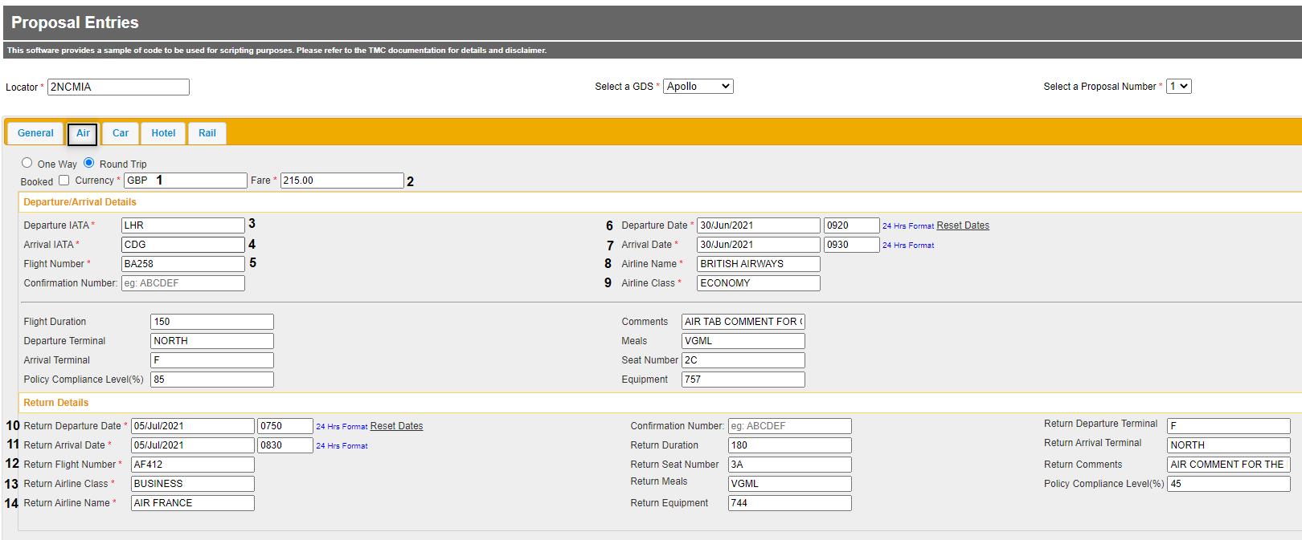

### Air Tab round trip output display

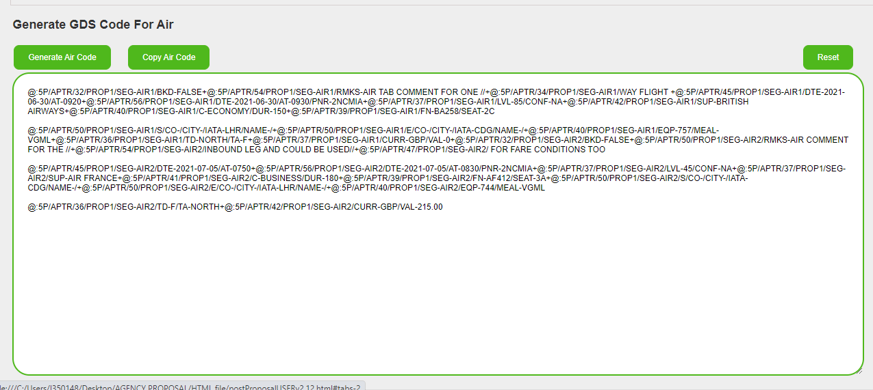

## Air Tab round trip table of definitions

### Air Tab round trip mandatory information

| File input  and description | PNR Remark label | PNR Remark examples |
| --- | --- | --- |
| AIR – Round Trip  This is the tab you are working on and the segment type. | SEG- | SEG-AIR1  SEG-AIR2 |
| (1) Currency  This is the three letter ISO standard code for the currency used for example: GBP, EUR, USD | CURR- | CURR-GBP |
| (2) Fare  This is the total amount of the Air segment.  It will automatically format to 2 decimal places if not typed.  We currently only support decimalized currencies | VAL- | VAL-215.00 |
| (3) Departure IATA  This is the IATA three-letter airport code for the departure. | IATA | IATA-LHR |
| (4) Arrival IATA  This is the IATA three-letter airport code for the arrival. | IATA | IATA-CDG |
| (5) Flight Number  This is the flight number and should be:  the airline two-letter IATA code followed by the flight number | FN- | FN-BA258 |
| (6) Confirmation Number  This is where you will add the provider reference if you have selected “Booked”.  This is only mandatory when Booked is checked | CONF- | CONF-ABCDEF  CONF-NA  (default value if blank) |
| (7) Departure Date and Time  (8) Arrival Date and Time  This is the departure and or arrival date and time with the following format:   * Date is in the format DD/MMM/YYYY * Time is in the format HHMM and is 24 hours | DTE-…/AT- | DTE-2021-06-30/AT-0920  DTE-2021-06-30/AT-0920 |
| (9) Airline Class  This is the cabin class description in full, not just the letter. | C- | C-ECONOMY |
| (10) Return Departure Date and Time  (11) Return Arrival Date and Time  This is the return departure date using the following format:   * Date is in the format DD/MMM/YYYY * Time is in the format HHMM and is 24 hours | DTE-…/AT- | SEG-AIR2/DTE-2021-07-05/AT-0750  SEG-AIR2/DTE-2021-07-05/AT-0830 |
| (12) Return Flight Number  This is the return flight number and should be:  the airline two-letter IATA code followed by the flight number | FN- | FN-AF412 |
| (13) Return Airline Class  This is the return cabin class description in full. | C- | SEG-AIR2/C-BUSINESS |

### Air Tab round trip optional information

| File input  and description | PNR Remark label | PNR Remark example |
| --- | --- | --- |
| Booked  Select this if the flight you are detailing is booked (eg: low-cost carrier). | BKD- | BKD-FALSE  (default value) |
| Confirmation Number  This is where you will add the provider reference if applicable.  This is optional when “Booked” is not selected. | CONF- | CONF-ABCDEF  CONF-NA  (default value if blank) |
| Flight Duration  This is for the flight duration information in minutes. | DUR- | DUR-150  (shows as DUR-/ if blank) |
| Departure Terminal  This is where you add the departure terminal information. | TD- | TD-NORTH  (not shown if blank) |
| Arrival Terminal  This is where you add the arrival terminal information. | TA- | TA-SOUTH  (not shown if blank) |
| Policy Compliance Level(%)  This will be a value between 0-100 that matches the segment compliance (100 if fully compliant and 0 if not compliant at all). | LVL- | LVL-85  (shows as LVL-/ if blank) |
| Comments  This is where any additional comments related to the air segment can be added as free text.  For example, the fare conditions or any information that you want to pass to the traveler. | RMKS- | RMKS-ONE WAY TEST  (not shown if blank) |
| Meals  This is where you add the meal information. It should be entered as the meal code. In our example, it is a vegetarian meal. | MEAL- | MEAL-VGML  (not shown if blank) |
| Seat Number  This is where you add the seat number. It is free text. | SEAT- | SEAT-2C  (not shown if blank) |
| Equipment  This is where you add the equipment information if required. | EQP- | EQP-757  (not shown if blank) |
| Return Duration  This is the return flight duration in minutes. | DUR- | DUR-180  (shows as DUR-/ if blank) |
| Return Seat Number  This is where you enter the seat number for the inbound flight. | SEAT- | SEAT-3A  (not shown if blank) |
| Return Meals  This is where you add the meal information for the inbound flight. It should be entered as the meal code. In our example, it is a vegetarian meal. | MEAL- | MEAL-VGML  (not shown if blank) |
| Return Equipment  This is where you can add the equipment information for the inbound flight. | EQP- | EQP-744  (not shown if blank) |
| Return Departure Terminal  This is where you give the departure terminal information. | TD- | TD-F  (not shown if blank) |
| Return Arrival Terminal  This is where you give the arrival terminal information. | TA- | TA-NORTH  (not shown if blank) |
| Return Comments  This is where any additional comments can be added.  For example, the fare conditions. | RMKS- | RMKS-AIR COMMENT FOR THE INBOUND LEG AND COULD BE USED FOR FARE CONDITIONS TOO  (not shown if blank) |
| Return Policy Compliance Level(%)  This will be a value between 0-100 that matches the segment compliance (100 if fully compliant and 0 if not compliant at all) for the inbound flight. | LVL- | LVL-85  (shows as LVL-/ if blank) |

## CAR TAB

This is where all the details regarding the information for a Car segment should be added.

## Car Tab completion flow

Flow

Fill in any optional information required

* “Confirmation Number” – only when “Booked” is unchecked
* “Pickup” and “Drop Off” IATA
* “Class”
* “Drop Off Details”
* “Policy Compliance Level (%)”
* “Comments”
* “Transmission Preference”
* “Pickup Phone”
* “Drop Off Phone”
* “Additional Equipment”
* “Air Conditioning”
* “Airport Pickup”
* “Airport Drop Off”

Copy and Paste into the GDS Container PNR

Fill in the mandatory fields

Marked with a red asterisk

* Check or uncheck “Booked” where applicable
* “Pickup Country Code”
* “Pickup City”
* “Pickup Details”
* “Confirmation Number” – only when “Booked” is checked
* “Drop Off Country Code”
* “Drop Off City”
* “Supplier Name”
* “Pickup Date” and “Time”
* “Drop Off Date” and “Time”
* “Currency”
* “Rate”

Click on “Generate Car Code”

## Car Tab screenshot example

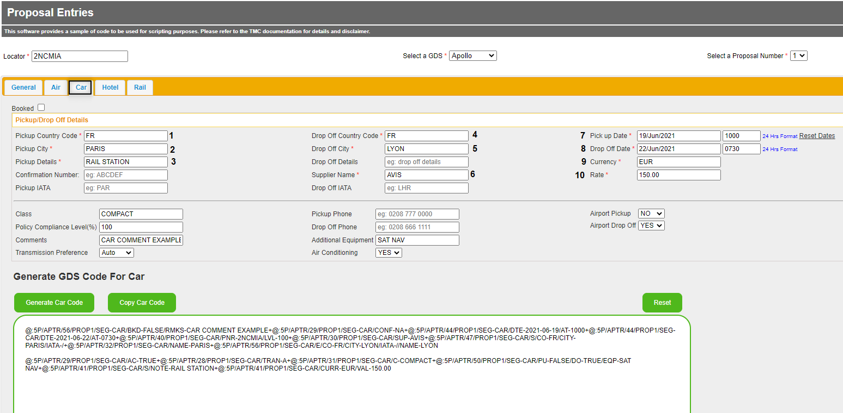

## Car Tab table of definitions

### Car Tab mandatory information

| File input  and description | PNR Remark label | PNR Remark examples |
| --- | --- | --- |
| CAR  This is the tab and the segment type. | SEG- | SEG-CAR |
| (1) Pickup Country Code  This is the pickup two-letter IATA country code. | CO- | CO-FR |
| (2) Pickup City  This is the pickup city name in full. | CITY- | CITY-PARIS |
| (3) Pickup Details  This is where you enter the details about the pickup. | NOTE- | NOTE-RAIL STATION |
| (4) Confirmation Number  This is where you will add the provider reference if you have selected “Booked”.  This is only mandatory when “Booked” is checked | CONF- | CONF-ABCDEF  CONF-NA  (default value if blank) |
| (5) Drop Off Country Code  This is the drop off two-letter IATA country code. | CO- | CO-FR |
| (6) Drop Off City  This is the drop off city name in full. | CITY- | CITY-LYON |
| (7) Supplier Name  This is the supplier name in full. | SUP- | SUP-AVIS |
| (8) Pickup Date and Time  This is the pickup date and time using the following format:   * Date is in the format DD/MMM/YYYY * Time is in the format HHMM and is 24 hours | DTE-…/AT-… | DTE-2021-06-19/AT-1000 |
| (9) Drop Off Date and Time  This is the drop off date and time using the following format:   * Date is in the format DD/MMM/YYYY * Time is in the format HHMM and is 24 hours | DTE-…/AT-… | DTE-2021-06-22/AT-0730 |
| (10) Currency  This is the three-letter ISO standard code for the currency used. For example: GBP, EUR, USD… | CURR- | CURR-EUR |
| (11) Rate  This is the total amount of the Car segment.  It will automatically format to 2 decimal places if not typed.  We currently only support decimalized currencies. | VAL- | VAL-150.00 |

### Car Tab optional information

| File input  and description | PNR Remark label | PNR Remark examples  with default values |
| --- | --- | --- |
| Booked  If you have booked the car and selected this field, the “Confirmation Number” will become mandatory. | BKD- | BKD-TRUE  or  BKD-FALSE  (default value) |
| Confirmation Number  This is where you enter the booking reference obtained from the provider if applicable.  This is optional when “Booked” is not selected. | CONF- | CONF-14545  or  CONF-NA  (default value) |
| Pickup IATA  This is the three-letter city code of the pickup city. | IATA- | IATA-PAR  (not shown if blank) |
| Drop Off Details  This is where you can add any information regarding the drop off. | NOTE- | NOTE-AT HILTON RECEPTION  (not shown if blank) |
| Drop Off IATA  This is the three-letter city code of the drop off city. | IATA- | IATA-LYS  (not shown if blank) |
| Class  This is where you add the car category in full. | C- | C-COMPACT  (not shown if blank) |
| Policy Compliance Level (%)  This will be a value between 0-100 that matches the segment compliance (100 if fully compliant and 0 if not compliant at all). | LVL- | LVL-100  (shows as LVL-/ if blank) |
| Comments  This is where you can add any free text additional information regarding the car segment. | RMKS- | RMKS-CAR COMMENT EXAMPLE  (not shown if blank) |
| Transmission Preference  This is where you choose the car transmission in the drop-down menu. | TRAN- | TRAN-A  (default value) |
| Pickup Phone  Here you can enter the pickup office phone number. | PUPH- | PUPH-1233333333  (not shown if blank) |
| Drop Off Phone  Here you can enter the drop off office phone number. | DOPH- | DOPH-415747777  (not shown if blank) |
| Additional Equipment  This is where you can add any car feature/equipment required. It is free text. | EQP- | EQP-SAT NAV  (not shown if blank) |
| Air Conditioning  Select from the drop-down as preferred. | AC- | AC-TRUE  (default is FALSE) |
| Airport Pickup  This is a drop-down menu where you select if the pickup will be at the airport or not. | PU- | PU-FALSE  (default value) |
| Airport Drop Off  This is a drop-down menu where you select if the drop off will be at the airport or not. | DO- | DO-TRUE  (default is FALSE) |

# HOTEL TAB

This is where all the details regarding the proposal for a Hotel segment are added.

## Hotel Tab completion flow

Flow

Fill in any optional information required

* “Confirmation Number” – only when “Booked” is unchecked
* “Destination IATA”
* “Location Details”
* “Hotel Address”
* “Hotel ZIP Code”
* “Phone Number”
* “Policy Compliance Level (%)”
* “Room Type”
* “Comments”

Copy and Paste into the GDS Container PNR

Fill in **all** mandatory fields

Marked with a red asterisk

* Check or uncheck “Booked” where applicable
* “Country Code”
* “Destination City”
* “Hotel Name”
* “Check-in Date” and Time
* “Check-out Date” and Time
* “Confirmation Number” – only when “Booked” is checked
* “Supplier Name”
* “Currency”
* “Rate”

Click on “Generate Hotel Code”

## Hotel Tab screenshot example

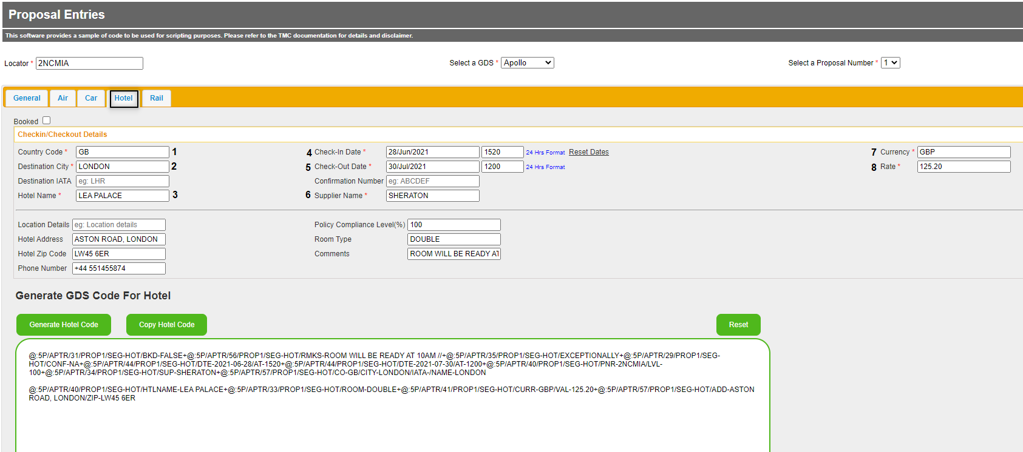

## Hotel Tab table of definitions

### Hotel Tab mandatory information

| File input  and description | PNR Remark label | PNR Remark examples |
| --- | --- | --- |
| HOTEL  This is the tab name and the segment type. | SEG- | SEG-HOT |
| (1) Country Code  This is the destination two-letter country code. | CO- | CO-GB |
| (2) Destination City  This is the destination city name in full | CITY- | CITY-LONDON |
| (3) Hotel Name  This is where you enter the hotel name. | HTLNAME- | HTLNAME-LEA PALACE |
| (4) Check-In Date and Time  This is the check-in date and time using the following format:   * Date is in the format DD/MMM/YYYY * Time is in the format HHMM and is 24 hours | DTE-…/AT- | DTE-2021-06-28/AT-1520 |
| (5) Check-Out Date and Time  This is the check-out date and time using the following format:   * Date is in the format DD/MMM/YYYY * Time is in the format HHMM and is 24 hours | DTE-…/AT- | DTE-2021-06-30/AT-1200 |
| (6) Confirmation Number  This is where you will add the provider reference if you have selected “Booked”.  This is only mandatory when Booked is checked. | CONF- | CONF-ABCDEF  CONF-NA  (default value if blank) |
| (7) Supplier Name  This is where you enter the supplier name in full. | SUP- | SUP-SHERATON |
| (8) Currency  This is the three-letter ISO standard code for the currency used (eg GBP, EUR). | CURR- | CURR-GBP |
| (9) Rate  This is the total amount of the Hotel segment.  It will automatically format to 2 decimal places if not typed.  We currently only support decimalized currencies. | VAL- | VAL-125.20 |

## Hotel Tab optional information

| File input  and description | PNR Remark label | PNR Remark examples  with default value information |
| --- | --- | --- |
| Destination IATA  This is the IATA three-letter code of the destination city. | IATA- | IATA-LYS  (shows as IATA-/ if blank) |
| Booked  If you check “Booked”, the “Confirmation Number” field will become mandatory. | BKD- | BKD-FALSE  (default value) |
| Confirmation Number    This is where you add the provider confirmation number if the hotel has been booked directly with the provider.  This is optional when “Booked” is not selected. | CONF- | CONF-A123456  or  CONF-NA  (default value) |
| Location Details  This is a free text field where you can add information about the hotel location. | NOTE- | NOTE-DOWNTOWN  (not shown if blank) |
| Hotel Address  This is where you add the hotel address information. | ADD- | ADD-ASTON ROAD, LONDON  (not shown if blank) |
| Hotel Zip Code  This is the zip code of the hotel location | ZIP- | ZIP-LW45 6ER  (not shown if blank) |
| Phone Number  This is where you add the hotel phone number | PH- | PH-0044 1256321  (not shown if blank) |
| Policy Compliance Level (%)  This will be a value between 0-100 that matches the segment compliance (100 if fully compliant and 0 if not compliant at all). | LVL- | LVL-100  (shows as LVL-/ if blank) |
| Room Type  This is where you can enter the room type in full.  It is free text. | ROOM- | ROOM-DOUBLE  (not shown if blank) |
| Comments  This is where you can add any additional comments such as cancellation policy. | RMKS- | RMKS-24HR CXX POLICY  (not shown if blank) |

## RAIL TAB

This is where all the details regarding the rail segment are added.

## Rail Tab completion flow for one-way rail

Flow

Fill in any optional information required

* “Confirmation Number” – only when “Booked” is unchecked
* “Class of Services”
* “Duration”
* “Train Number”
* “Wagon Number”
* “Seat Number”
* “Policy Compliance Level (%)”
* “Comments”

Copy and Paste into the GDS Container PNR

Fill in **all** mandatory fields

Marked with a red asterisk

* Select “One Way”
* Check or uncheck “Booked” as applicable
* “Currency”
* “Fare”
* “Booking Source”
* “Departure Country Code”
* “Departure Station Name”
* “Confirmation Number” – only when “Booked” is checked
* “Arrival Country Code”
* “Arrival Station Name”
* “Carrier Name”
* “Departure Date” and “Time”
* “Arrival Date” and “Time”

Click on “Generate Rail Code”

## Rail Tab one-way screenshot example

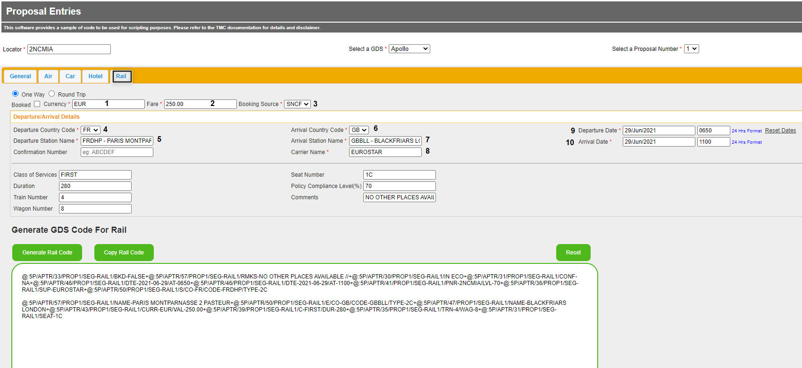

## Rail Tab one-way table of definitions

### Rail Tab one-way mandatory information

| File input  and description | PNR Remark label | PNR Remark examples |
| --- | --- | --- |
| RAIL – One Way  This is the tab name and the segment type. | SEG- | SEG-RAIL1 |
| Booked  Check the field “Booked” if you have confirmed the booking with the provider. The “Confirmation Number” field will then become mandatory. | BKD- | BKD-FALSE  (default value) |
| (1) Currency  This is the three-letter ISO standard code for the currency used (eg GBP, EUR). | CURR- | CURR-EUR |
| (2) Fare  This is the total amount of the rail segment.  It will automatically format to 2 decimal places if not typed.  We currently only support decimalized currencies. | VAL- | VAL-250.00 |
| (3) Booking Source  This is the rail provider booking source. It is a drop-down menu of the supported providers. | TYPE- | TYPE-2C |
| (4) Departure Country Code  This is the two-letter IATA departure country code. | CO- | CO-FR |
| (5) Departure Station Name  This is the departure station name from the drop down provided and includes the departure rail station code. Items in the list are supplier specific. | CODE-  NAME- | CODE-FRDHP  NAME-PARIS MONTPARNASSE 2 PASTEUR |
| (6) Confirmation Number  This is where you will add the provider reference if you have selected “Booked”. This is only mandatory when Booked is checked. | CONF- | CONF-A123456  or  CONF-NA  (default value) |
| (7) Arrival Country Code  This is the two-letter IATA arrival country code.  It is a drop-down menu. | CO- | CO-GB |
| (8) Arrival Station Name  This is the arrival station name from the drop down provided and includes the rail station code. Items in the list are supplier specific. | CODE-  NAME- | CODE-GBBLL  NAME-BLACKFRIARS LONDON |
| (9) Carrier Name  This is the carrier name in full. | SUP- | SUP-EUROSTAR |
| (10) Departure Date and Time  This is the departure date and time using the following format:   * Date is in the format DD/MMM/YYYY * Time is in the format HHMM and is 24 hours | DTE-…/AT- | DTE-2021-06-29/AT-0850 |
| (11) Arrival Date and Time  This is the arrival date and time using the following format:   * Date is in the format DD/MMM/YYYY * Time is in the format HHMM and is 24 hours | DTE-…/AT- | DTE-2021-07-29/AT-1100 |

### Rail Tab one-way optional information

| File input  and description | PNR Remark label | PNR Remark examples  with default value information |
| --- | --- | --- |
| Booked  Check the field “Booked” if you have confirmed the booking with the provider. “Confirmation Number” field will then become mandatory | BKD- | BKD-FALSE  (default value) |
| Confirmation Number    This is where you add the provider confirmation number if applicable. This is optional if “Booked” is not checked. | CONF- | CONF-A12345  or  CONF-NA  (default value) |
| Class of Services  This is the class of services in full. | C- | C-STANDARD  (not shown if blank) |
| Duration  This is the trip duration in minutes. | DUR- | DUR-280  (shows as DUR-/ if blank) |
| Train Number  This is where you add the train number. | TRN- | TRN-4  (not shown if blank) |
| Wagon Number  This is where you add the wagon number. | WAG- | WAG-8  (not shown if blank) |
| Seat Number  This is where you add the seat number. | SEAT- | SEAT-1C  (not shown if blank) |
| Policy Compliance Level (%)  This will be a value between 0-100 that matches the segment compliance (100 if fully compliant and 0 if not compliant at all). | LVL- | LVL-70  (shows as LVL-/ if blank) |
| Comments  This is where you add any free text information. | RMKS- | RMKS-QUIET ZONE AVAILABLE  (not shown if blank) |

## Rail Tab completion flow for round trip rail

Flow

Fill in any optional information required

* Check or uncheck “Booked” as applicable
* “Class of Services”
* “Duration”
* “Train Number”
* “Wagon Number”
* “Seat Number”
* “Policy Compliance Level (%)”
* “Comments”
* “Return Confirmation Number”
* “Return Policy Compliance Level(%)”
* “Return Class of Service”
* “Return Duration”
* “Return Train Number”
* “Return Wagon Number”
* “Return Seat Number”
* “Return Comments”

Copy and Paste into the GDS Container PNR

Fill in **all** mandatory fields

Marked with a red asterisk

* Select “Round Trip”
* Check or uncheck “Booked” as applicable
* “Currency”
* “Fare”
* “Booking source”
* “Departure Country Code”
* “Departure Station Name”
* “Arrival Country Code”
* “Arrival Station Name”
* “Carrier Name”
* “Departure Date” and “Time”
* “Arrival Date” and “Time”
* “Return Departure Date” and Time
* “Return Arrival Date” and Time
* “Return Carrier Name”

Click on “Generate Rail Code”

## Rail Tab round trip screenshot examples

### Rail Tab round trip input display

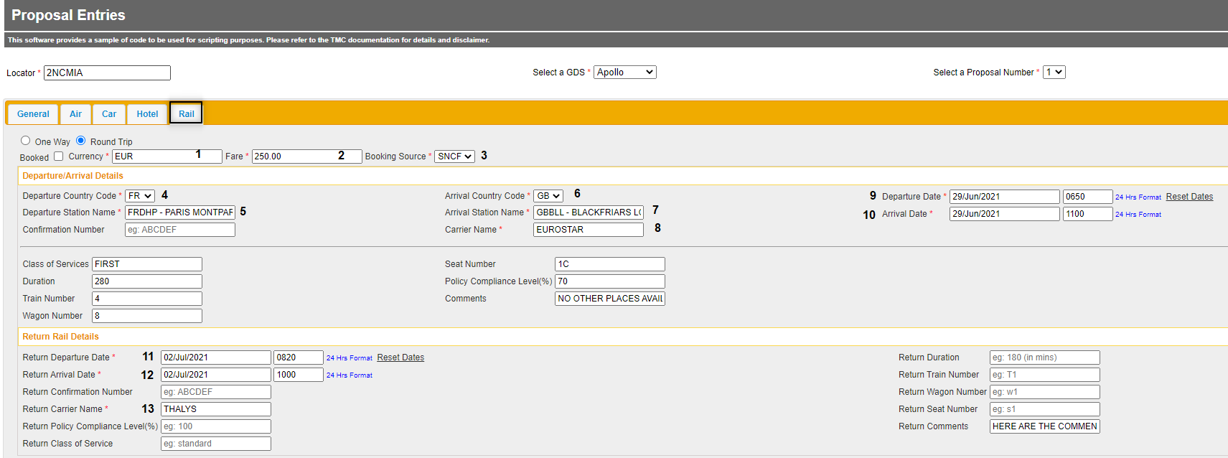

### Rail Tab round trip output display

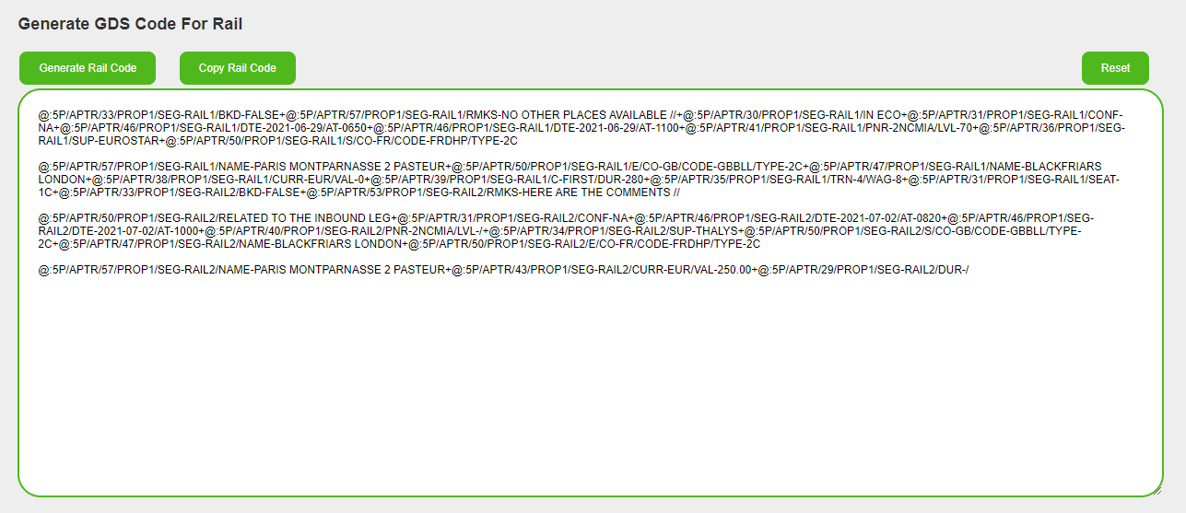

## Rail Tab round trip table of definitions

### Rail Tab round trip mandatory information

| File input  and description | PNR Remark label | PNR Remark examples |
| --- | --- | --- |
| RAIL – Round Trip  This is the tab name and the segment type. | SEG- | SEG-RAIL1  SEG-RAIL2 |
| (1) Currency  This is the three-letter ISO standard code for the currency used (eg GBP, EUR). | CURR- | CURR-EUR |
| (2) Fare  This is the total amount of the rail segment.  Automatically formatted to 2 decimal places if not typed.  We currently only support decimalized currencies. | VAL- | VAL-250.00 |
| (3) Booking Source  This is the rail provider booking source. It is a drop-down menu of currently supported rail providers. | TYPE- | TYPE-2C |
| (4) Departure Country Code  This is the two-letter IATA departure country code. | CO- | CO-FR |
| (5) Departure Station Name  This is the departure station name from the drop down provided and includes the departure rail station code.  Items in the list are supplier specific. | CODE-  NAME- | CODE-FRDHP  NAME-PARIS MONTPARNASSE 2 PASTEUR |
| (6) Confirmation Number  This is where you will add the provider reference if you have selected “Booked”.  This is only mandatory when “Booked” is checked. | CONF- | CONF-A123456  or  CONF-NA  (default value) |
| (7) Arrival Country Code  This is the two-letter IATA arrival country code.  It is a drop-down menu. | CO- | CO-GB |
| (8) Arrival Station Name  This is the arrival station name from the drop down provided in the file and includes the rail station code.  Items in the list are supplier specific. | CODE-  NAME- | CODE-GBBLL  NAME-BLACKFRIARS LONDON |
| (9) Carrier Name  This is the carrier name in full. | SUP- | SUP-EUROSTAR |
| (10) Departure Date and Time  This is the departure date and time using the following format:   * Date is in the format DD/MMM/YYYY * Time is in the format HHMM and is 24 hours | DTE-…/AT- | DTE-2021-06-29/AT-0850 |
| (11) Arrival Date and Time  This is the arrival date and time using the following format:  • Date is in the format DD/MMM/YYYY  • Time is in the format HHMM and is 24 hours | DTE-…/AT- | DTE-2021-07-29/AT-1100 |
| (12) Return Departure Date  This is the return departure date and time using the following format:  • Date is in the format DD/MMM/YYYY  • Time is in the format HHMM and is 24 hours | DTE-…/AT- | DTE-2021-07-02/AT-0820 |
| (13) Return Arrival Date  This is the return arrival date and time using the following format:  • Date is in the format DD/MMM/YYYY  • Time is in the format HHMM and is 24 hours | DTE-…/AT- | DTE-2021-07-02/AT-1000 |
| (14) Return Carrier Name  This is the return carrier name in full. | SUP- | SUP-THALYS |

### Rail Tab round trip optional information

| File input  and description | PNR Remark label | PNR Remark examples  with default values |
| --- | --- | --- |
| Booked  Check the field “Booked” if you have confirmed the booking with the provider. The “Confirmation Number” field will then become mandatory. | BKD- | BKD-FALSE  (default value) |
| Confirmation Number    This is where you add the provider confirmation number if applicable.  This is optional when “Booked” is not selected. | CONF- | CONF-B12345  or  CONF-NA  (default value) |
| Class of Services  This is the class of services in full, not just the letter. | C- | C-STANDARD  (not shown if blank) |
| Duration  This is the trip duration in minutes. | DUR- | DUR-280  (shows as DUR-/ if blank) |
| Train Number  This is where you add the train number. | TRN- | TRN-4  (not shown if blank) |
| Wagon Number  This is where you add the wagon number. | WAG- | WAG-8  (not shown if blank) |
| Seat Number  This is where you add the seat number. | SEAT- | SEAT-1C  (not shown if blank) |
| Policy Compliance Level (%)  This will be a value between 0-100 that matches the segment compliance (100 if fully compliant and 0 if not compliant at all). | LVL- | LVL-70  (shows as LVL-/ if blank) |
| Comments  This is where you add any free text information. | RMKS- | RMKS-QUIET ZONE AVAILABLE  (not shown if blank) |
| Return Confirmation Number    This is where you add the provider confirmation number if the rail travel has been booked directly with the provider.  This is optional if “Booked” is not selected. | CONF- | CONF-NA  (default value) |
| Return Class of Services  This is the class of services in full, not just the letter. | C- | C-STANDARD  (not shown if blank) |
| Return Duration  This is the return trip duration in minutes. | DUR- | DUR-60  (shows as DUR-/ if blank) |
| Return Train Number  This is where you add the train number. | TRN- | TRN-Z202  (not shown if blank) |
| Return Wagon Number  This is where you add the wagon number. | WAG- | WAG-G2  (not shown if blank) |
| Return Seat Number  This is where you add the seat number. | SEAT- | SEAT-24A  (not shown if blank) |
| Return Policy Compliance Level (%)  This will be a value between 0-100 that matches the segment compliance (100 if fully compliant and 0 if not compliant at all). | LVL- | LVL-100  (shows as LVL-/ if blank) |
| Return Comments  This is where you add any free text information. | RMKS- | RMKS-HERE ARE THE COMMENTS RELATED TO THE RETURN TRAVEL  (not shown if blank) |

## CONCATENATION

Remark concatenation allows for multiple remark lines to be copied in a single block. Where the maximum number of concatenations has been reached, a new remark block will be created. This ensures that the minimum number of copy and paste actions is required.

For more information on configuring concatenation, please see Configuration above.

Example of blocks:

@:5P/APTR/33/PROP1/SEG-RAIL1/BKD-FALSE+@:5P/APTR/57/PROP1/SEG-RAIL1/RMKS-NO OTHER PLACES AVAILABLE //+@:5P/APTR/30/PROP1/SEG-RAIL1/IN ECO+@:5P/APTR/31/PROP1/SEG-RAIL1/CONF-NA+@:5P/APTR/46/PROP1/SEG-RAIL1/DTE-2021-06-29/AT-0650+@:5P/APTR/46/PROP1/SEG-RAIL1/DTE-2021-06-29/AT-1100+@:5P/APTR/41/PROP1/SEG-RAIL1/PNR-2NCMIA/LVL-70+@:5P/APTR/36/PROP1/SEG-RAIL1/SUP-EUROSTAR+@:5P/APTR/50/PROP1/SEG-RAIL1/S/CO-FR/CODE-FRDHP/TYPE-2C

@:5P/APTR/57/PROP1/SEG-RAIL1/NAME-PARIS MONTPARNASSE 2 PASTEUR+@:5P/APTR/50/PROP1/SEG-RAIL1/E/CO-GB/CODE-GBBLL/TYPE-2C+@:5P/APTR/47/PROP1/SEG-RAIL1/NAME-BLACKFRIARS LONDON+@:5P/APTR/38/PROP1/SEG-RAIL1/CURR-EUR/VAL-0+@:5P/APTR/39/PROP1/SEG-RAIL1/C-FIRST/DUR-280+@:5P/APTR/35/PROP1/SEG-RAIL1/TRN-4/WAG-8+@:5P/APTR/31/PROP1/SEG-RAIL1/SEAT-1C+@:5P/APTR/33/PROP1/SEG-RAIL2/BKD-FALSE+@:5P/APTR/53/PROP1/SEG-RAIL2/RMKS-HERE ARE THE COMMENTS //

@:5P/APTR/50/PROP1/SEG-RAIL2/RELATED TO THE INBOUND LEG+@:5P/APTR/31/PROP1/SEG-RAIL2/CONF-NA+@:5P/APTR/46/PROP1/SEG-RAIL2/DTE-2021-07-02/AT-0820+@:5P/APTR/46/PROP1/SEG-RAIL2/DTE-2021-07-02/AT-1000+@:5P/APTR/40/PROP1/SEG-RAIL2/PNR-2NCMIA/LVL-/+@:5P/APTR/34/PROP1/SEG-RAIL2/SUP-THALYS+@:5P/APTR/50/PROP1/SEG-RAIL2/S/CO-GB/CODE-GBBLL/TYPE-2C+@:5P/APTR/47/PROP1/SEG-RAIL2/NAME-BLACKFRIARS LONDON+@:5P/APTR/50/PROP1/SEG-RAIL2/E/CO-FR/CODE-FRDHP/TYPE-2C

@:5P/APTR/57/PROP1/SEG-RAIL2/NAME-PARIS MONTPARNASSE 2 PASTEUR+@:5P/APTR/43/PROP1/SEG-RAIL2/CURR-EUR/VAL-250.00+@:5P/APTR/29/PROP1/SEG-RAIL2/DUR-/+@:5P/APTR/35/PROP1/SEG-RAIL2/TRN-6/WAG-8

# Remark separatorS

Remark entries use a single forward slash between fields but may also contain a double forward slash for long remark content.

The single forward slash **/** denotes the end of a field and the beginning of the next field.

Aforward slash **/** is a **reserved character** and should **not** be added in any field.

The double forward slash **//** denotes that the content is longer than the line length permitted by the GDS. The remaining content is then split into a new entry or entries with no label. The number of splits will depend on how many are required.

Double slash example:

@:5P/APTR/54/PROP1/SEG-AIR2/RMKS-**COMMENTS FOR THE RETURN**

//+@:5P/APTR/34/PROP1/SEG-AIR2/**AIR SEGMENT**

# VERSION HISTORY

| **Data Formatter for Concur Request Version Number** | Amendments dates |
| --- | --- |
| V2.10  v2.11  v2.12  v2.12.1 | **02Jun21**  ALL TABS :   * Time - can now be entered manually only * Date - user can manually enter the date or use the calendar   AIR, CAR, HOTEL and RAIL TABS:   * Fare/Rate - two decimals will be added automatically if not entered in the corresponding field * Policy compliance - accept only numeric value between 0 and 100   AIR and RAIL TABS:   * Policy compliance - will now show for each leg in case of return trips   AIR TAB:   * Departure/Arrival Details - Mandatory and Optional information are now on the same block for the air one-way segment * Return Details - Mandatory and optional information are now on the same block   RAIL TAB:   * Departure/Arrival Details - Mandatory and optional information are now on the same block for the rail one-way segment * Return Details - Mandatory and optional information are now on the same block   CAR TAB:   * Drop Off Details - this field is now optional   OPTIONAL INFORMATION   * We will show the data in the remarks only if the value is entered in the file.(please refer to each optional field for each segment   **07Jun21**  CAR TAB   * Location data has now been added * Drop Off Details is now optional   ALL TABS   * Currency fields will now accept only alpha characters   AIR and RAIL TAB   * For return trips we have now all the information boxes on the same page   GENERATE CODE   * Introduction of the concatenation of the remarks   **28Jun21**   * Concatenation has been implemented * Bug fixes (Hotel Phone now populated in the remarks when added, double “/” in the car remarks)   **30Jun21**   * File name has been updated * UI updates (adding “Return” before “Confirmation number” and “Policy Compliance Level” fields) |

N.B. This document v1.2 is a guide for the file v2.12 and supersedes any previous documentation